* IP Address 192.168.1.105 found by using netdiscover -r 192.168.1.0/16
* Secret folder found using directory navigation by navigating to the 192.168.1.105 webpage and navigating to the companyfolder/company_culture/file1.txt which references the secret folder.

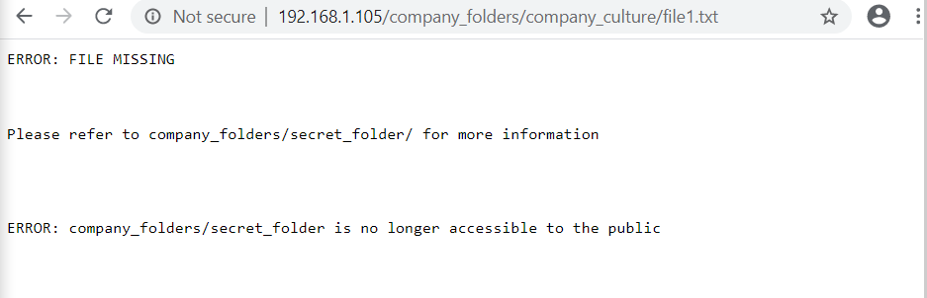

* Using hydra -l ashton -P /usr/share/wordlists/rockyou.txt -s 80 -f -vV 192.168.1.105 http-get /company_folders/secret_folder/ aston’s password is found to be leopoldo

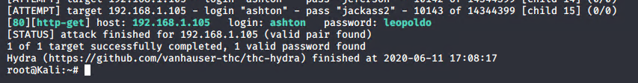

* With the username aston and the password leopoldo access was gained to the secret folder directory where a user ryan was found and the associated hash.

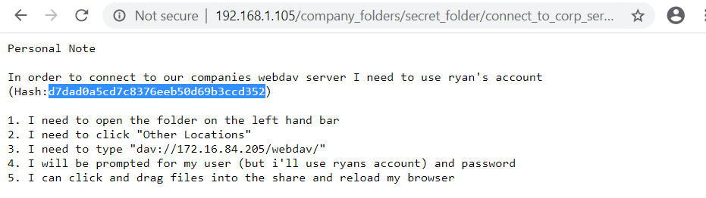

* Cracking the hash with crackstation.net yielded the password linux4u

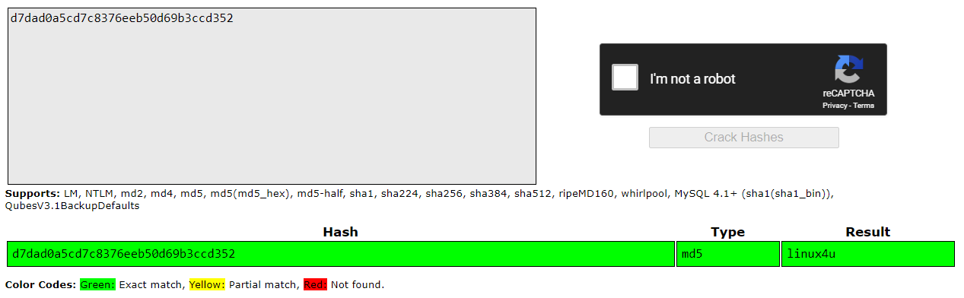

* With the user ryan and the password linux4u and the command ssh -l ryan 192.168.1.105 access was gained into the machine.

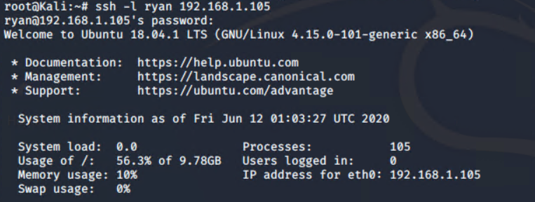

* Simple navigation to the root directory yielded the desired flag objective.

